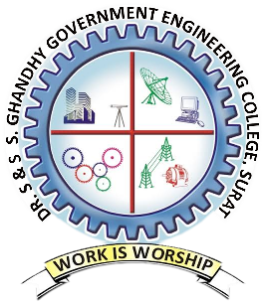
DR. S. & S. S. GHANDHY GOVERNMENT ENGINEERING COLLEGE – SURAT
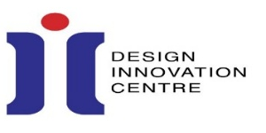
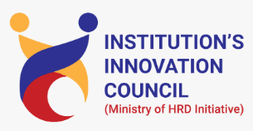


IIC, DIC & SSIP 2.0 CELL
REPORT

“Idea Generation for Innovations & Startups”

A seminar on “Idea Generation for Innovations & Startups” was organized on 26th February, 2026 (Thursday), from 4.00 PM to 5.00 PM under the aegis of IIC, DIC & SSIP 2.0 Cell of Dr. S. & S. S. Ghandhy Government Engineering College Surat. 94 students of the institute have participated in the event.
The session started by welcoming all the participants by the student anchors and the guests have been facilitated with flowers by event coordinator. The session was started by Dr. M. K. Chudasama and he has explained the meaning of Innovation and Idea generation for various technical innovations and it was very well received by the participants. The process of initiation of idea to research was illustrated with examples by the presentation. He briefly explained about startup ecosystem and importance of idea generation at academic level. Different techniques of idea generation like Brainstorming and SCAMPER technique were discussed at length with suitable examples. Awareness about IIC and various activities under IIC was also discussed. It was also explained to the students that for the problem solutions, they will get various mentorship and financial support through SSIP 2.0. Dr. M. K. Chudasama has shared his journey as an innovator with the participants and it was appreciated by the participants. It was also discussed that how innovations experiences help in career building by the speaker.
The event was concluded by event coordinator by thanking all the faculties and student participants for attending the event enthusiastically. The event was ended by the national anthem.

The photographs of the event are attached here for reference.
